**CUSTOMER**

CREATE TABLE CUSTOMER (CNAME VARCHAR(15) PRIMARY KEY ,CITY VARCHAR(20) NOT NULL );

**BRANCH**

CREATE TABLE BRANCH (BNAME VARCHAR(20) PRIMARY KEY,CITY VARCHAR(30) CHECK (CITY IN ('NAGPUR','DELHI','BANGALORE','BOMBAY')) NOT NULL);

**BORROW**

CREATE TABLE BORROW (LOANNO VARCHAR(8) PRIMARY KEY CHECK (LOANNO LIKE 'L%') ,CNAME VARCHAR(15),BNAME VARCHAR(20) ,AMOUNT FLOAT(8,2) NOT NULL CHECK (AMOUNT>0) , FOREIGN KEY (CNAME) REFERENCES CUSTOMER(CNAME), FOREIGN KEY (BNAME) REFERENCES BRANCH(BNAME));

**DEPOSIT**

CREATE TABLE DEPOSIT (ACTNO VARCHAR(5) CHECK (ACTNO LIKE 'D%') PRIMARY KEY,CNAME VARCHAR(15),BNAME VARCHAR(20) ,AMOUNT FLOAT(8,2) CHECK (AMOUNT>0) NOT NULL, FOREIGN KEY (CNAME) REFERENCES CUSTOMER(CNAME), FOREIGN KEY (BNAME) REFERENCES BRANCH(BNAME));

**CUSTOMER**

1. INSERT INTO CUSTOMER VALUES('ANIL','CALCUTTA');
2. INSERT INTO CUSTOMER VALUES('SUNIL','DELHI');
3. INSERT INTO CUSTOMER VALUES('MEHUL','BARODA');
4. INSERT INTO CUSTOMER VALUES('MANDAR','PATNA');
5. INSERT INTO CUSTOMER VALUES('MADHURI','NAGPUR');
6. INSERT INTO CUSTOMER VALUES('PRAMOD', 'NAGPUR');
7. INSERT INTO CUSTOMER VALUES('SANDIP','SURAT');
8. INSERT INTO CUSTOMER VALUES('SHIVANI','BOMBAY');
9. INSERT INTO CUSTOMER VALUES('KRANTI','BOMBAY');
10. INSERT INTO CUSTOMER VALUES('NAREN','BOMBAY');

**BRANCH**

1. INSERT INTO BRANCH(BNAME,CITY) VALUES ('VRCE','NAGPUR');
2. INSERT INTO BRANCH(BNAME,CITY) VALUES ('AJNI','NAGPUR');
3. INSERT INTO BRANCH(BNAME,CITY) VALUES ('KAROLBAGH','DELHI');
4. INSERT INTO BRANCH(BNAME,CITY) VALUES ('CHANDNI','DELHI');
5. INSERT INTO BRANCH(BNAME,CITY) VALUES ('DHARAMPETH','NAGPUR');
6. INSERT INTO BRANCH(BNAME,CITY) VALUES ('MG-ROAD','BANGALORE');
7. INSERT INTO BRANCH(BNAME,CITY) VALUES ('ANDHERI','BOMBAY');
8. INSERT INTO BRANCH(BNAME,CITY) VALUES ('NEHRU-PALACE','DELHI');
9. INSERT INTO BRANCH(BNAME,CITY) VALUES ('POWAI','BOMBAY');
10. INSERT INTO BRANCH(BNAME,CITY) VALUES ('VIRAR','BOMBAY');

**DEPOSIT**

1. INSERT INTO DEPOSIT VALUES ('D100','ANIL','VRCE',1000.00,'1995-03-01');
2. INSERT INTO DEPOSIT VALUES ('D101','SUNIL','AJNI',500.00,'1996-01-04');
3. INSERT INTO DEPOSIT VALUES ('D102','MEHUL','KAROLBAGH',3500.00,'1995-11-17');
4. INSERT INTO DEPOSIT VALUES ('D104','MADHURI','CHANDNI',1200.00,'1995-12-17');
5. INSERT INTO DEPOSIT VALUES ('D105','PRAMOD','MG-ROAD',3000.00,'1996-03-27');
6. INSERT INTO DEPOSIT VALUES ('D106','SANDIP','ANDHERI',2000.00,'1996-03-31');
7. INSERT INTO DEPOSIT VALUES ('D107','SHIVANI','VIRAR',1000.00,'1995-09-05');
8. INSERT INTO DEPOSIT VALUES ('D108','KRANTI','NEHRU-PLACE',5000.00,'1995-07-05');
9. INSERT INTO DEPOSIT VALUES ('D109',' MINU','POWAI',7000.00,'1995-08-01');

**BORROW**

1. INSERT INTO BORROW VALUES ('L201','ANIL','VRCE','1000.00');
2. INSERT INTO BORROW VALUES ('L206','MEHUL','AJNI','5000.00');
3. INSERT INTO BORROW VALUES ('L311','SUNIL','DHARAMPETH','3000.00');
4. INSERT INTO BORROW VALUES ('L321','MADHURI','ANDHERI','2000.00');
5. INSERT INTO BORROW VALUES ('L371','PRAMOD','VIRAR','8000.00');
6. INSERT INTO BORROW VALUES ('L481','KRANTI','NEHRU-PALACE','3000.00');
7. SELECT * FROM DEPOSIT;

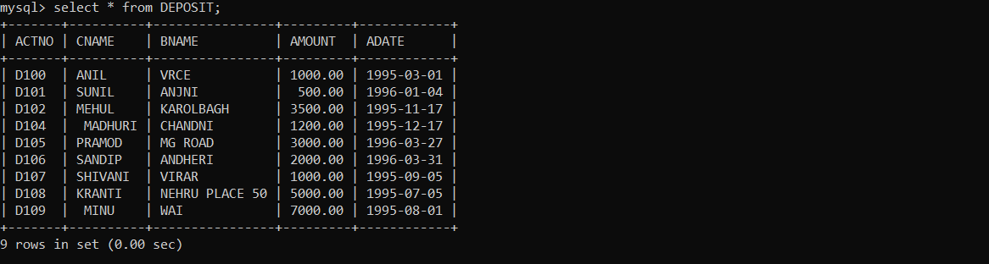

1. SELECT * FROM BORROW; 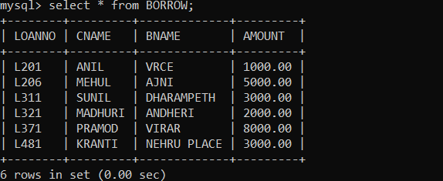
2. SELECT * FROM CUSTOMER;

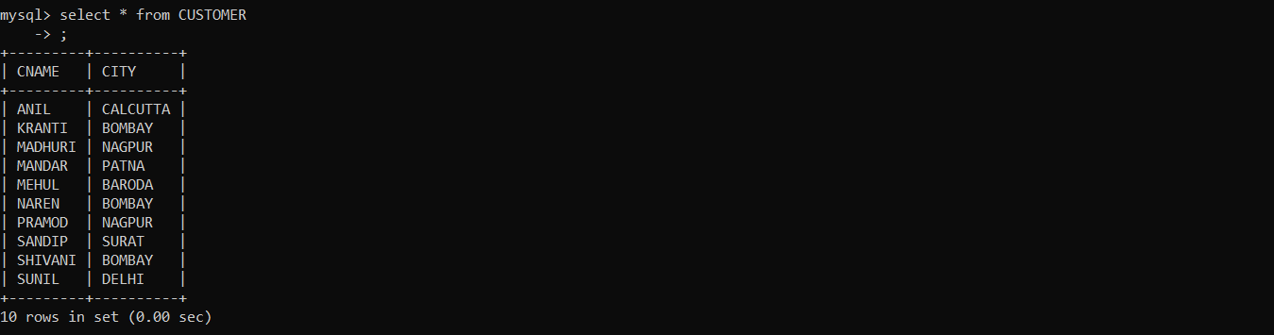

1. SELECT * FROM BRANCH;

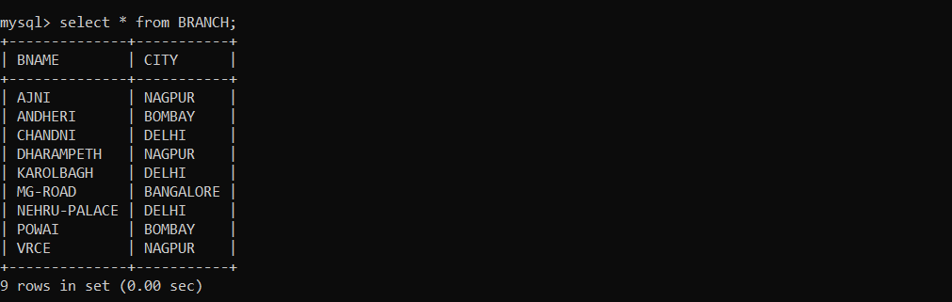

1. SELECT ACTNO,AMOUNT FROM DEPOSIT;

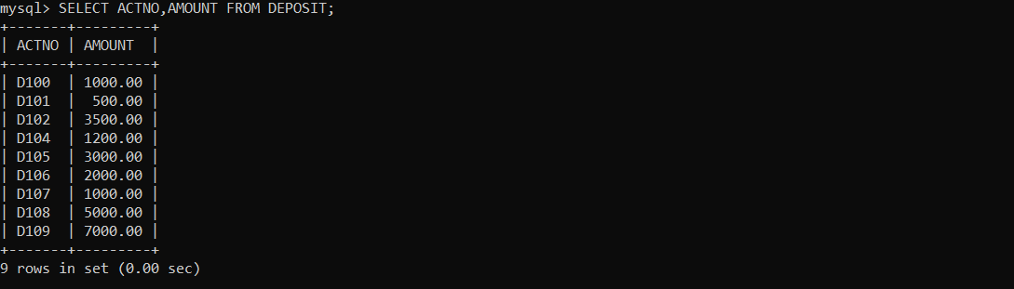

1. SELECT CNAME,ACTNO FROM DEPOSIT;

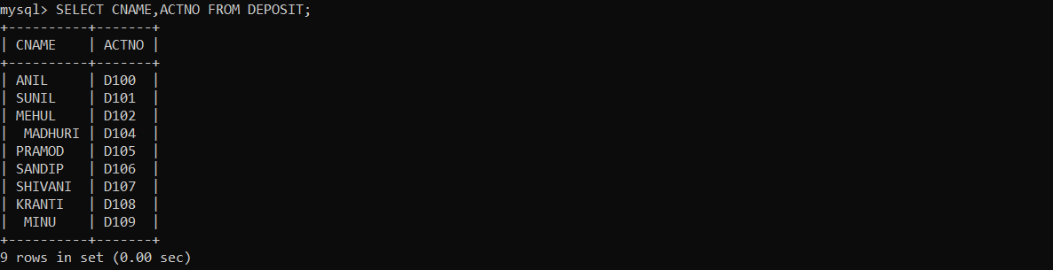

1. SELECT CNAME FROM CUSTOMER;

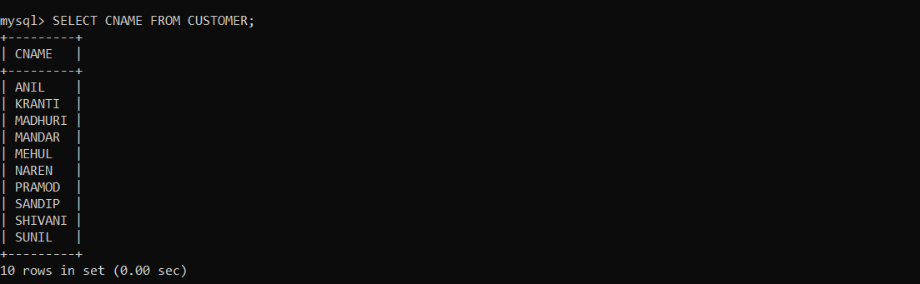

1. SELECT BNAME FROM BRANCH;

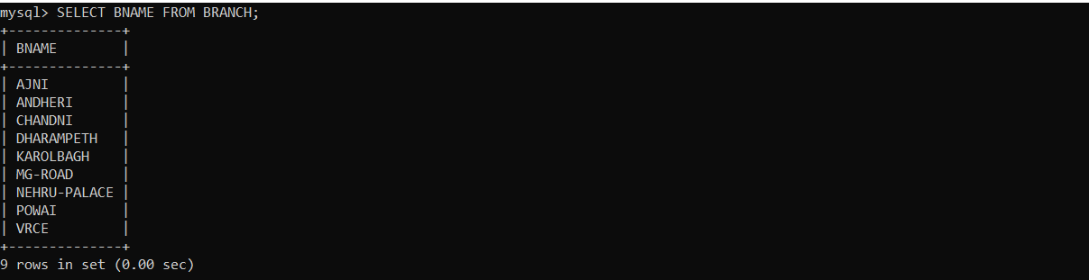

1. SELECT CNAME FROM BORROW;

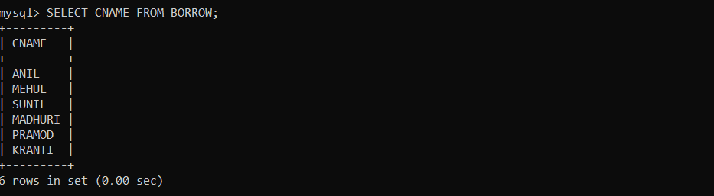

1. SELECT CNAME FROM CUSTOMER WHERE CITY=’NAGPUR’;

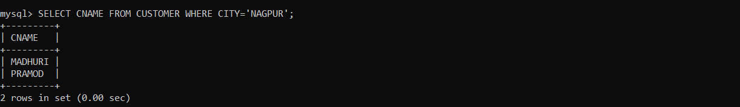

1. SELECT CNAME FROM DEPOSIT WHERE AMOUNT > 4000;

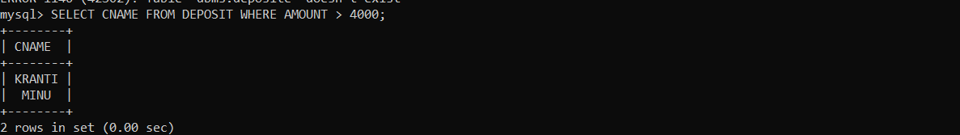

1. SELECT ADATE FROM DEPOSIT WHERE CNAME=’ANIL’;

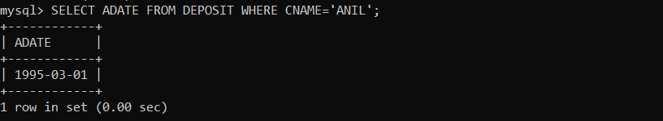

1. SELECT BNAME FROM BRANCH WHERE CITY=’BOMBAY’;

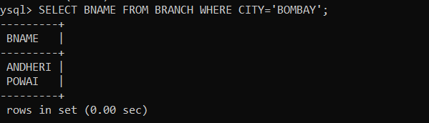

1. SELECT CNAME FROM BORROW WHERE LOANNO=’L201’;

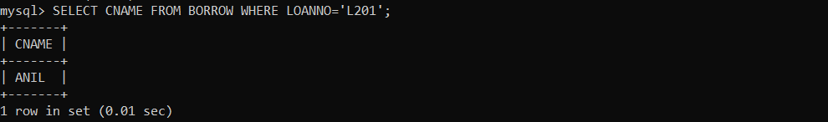

1. SELECT CNAME FROM DEPOSIT WHERE BNAME=’VRCE’;

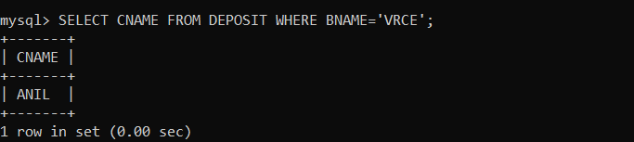

1. SELECT BNAME FROM BRANCH WHERE CITY=’DELHI’;

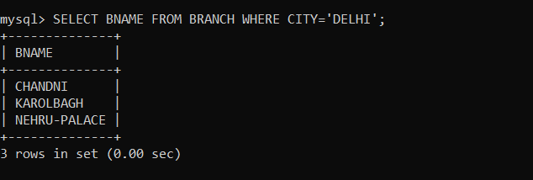

1. SELECT CNAME FROM DEPOSIT WHERE ADATE=’1995-12-17’;

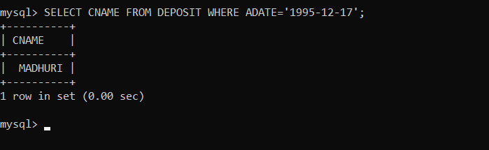

1. SELECT ACTNO,AMOUNT FROM DEPOSIT WHERE ADATE >=’1995-12-01’ AND ADATE <=’1996-05-01’;

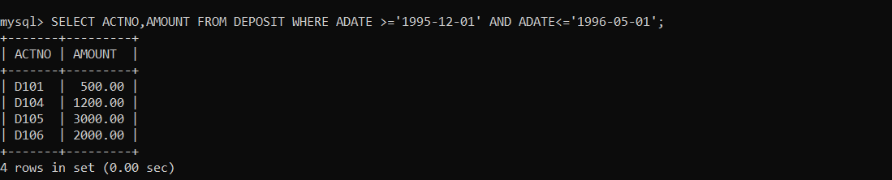

1. SELECT CITY FROM BRANCH WHERE BNAME=’KAROLBAGH’;

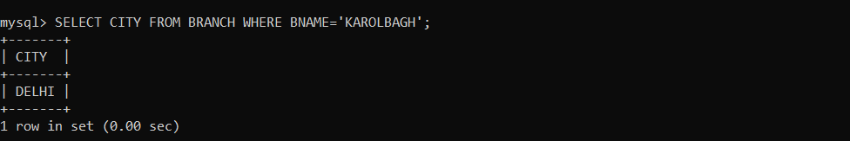

1. SELECT D.ACTNO,D.CNAME,D.BNAME,D.AMOUNT,B.LOANNO,B.AMOUNT FROM DEPOSIT D,BORROW B WHERE B.CNAME=’ANIL’ AND D.CNAME=’ANIL’;

